Information for
Incoming Companies

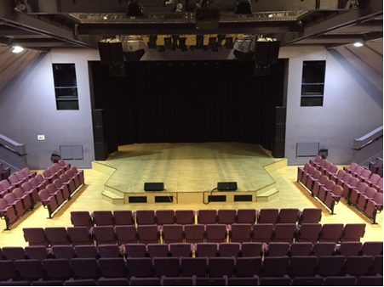

The Stables Theatre
Stockwell Lane
Wavendon
Milton Keynes
MK17 8LU

General
- The Stables is an internationally renowned music organisation with a vision to engage the widest range of people with music in all its diversity. It delivers its vision through its concert and event programme at The Stables Theatre in Wavendon, Milton Keynes. It also runs an extensive learning and participation programme in the venue and across the local area and produces a range of work in other spaces including the biennial IF: Milton Keynes International Festival.

History
- The world-renowned jazz musicians Sir John Dankworth and Dame Cleo Laine founded The Stables in 1970 in some outbuildings at their home as a venue for concerts and education activities. In October 2000, the new Stables Theatre opened its doors, with a second phase of development opening in 2007. It is now home to The Jim Marshall Auditorium with 398 and Stage 2 (80 seated or 120 standing) and presents around 400 concerts and 250 education sessions each year.

Directions
- From M1 Junction 14
Head towards Milton Keynes; At the first roundabout turn left onto the A5130
At the Kingston roundabout take the second exit signposted Wavendon/Woburn Sands, onto the A5130 (Newport Road)
Take the second right by the traffic lights onto the new access road, Dankworth Way
- From M1 Junction 13
Head towards Milton Keynes on A421
At the Kingston roundabout take the first exit signposted Wavendon/Woburn Sands, onto the A5130 (Newport Road)
Take the second right by the traffic lights onto the new road, Dankworth Way
• From anywhere
Head towards Milton Keynes - Aim for the junction of the A421 (H9 Groveway) and the A5130 at the Kingston roundabout - Take the turn signposted Wavendon –
Take the second right by the traffic lights onto the new access road, Dankworth Way

Jim Marshall Auditorium
Get In
- The main stage has a load in door of 2.7m wide by 3.9m high at stage level (.75m from road level) with direct access to stage left.
- It can be found as you enter The Stables site and drive to the left and the green load in door can be seen on your right.

Parking
- Vehicles may be left in the loading bay or adjacent staff car park

Access
- The Stables is highly accessible to artists with limited mobility
- Parking bays for blue badge holders are available directly outside the main entrance on a first come first served basis and there is one bay in the staff car park
- There is level step-free access from the staff car park to the backstage area, green room, dressing rooms and auditorium
- There is a stage lift for wheelchair users to access the stage area from stage left
- There is a passenger lift from the auditorium to the foyer area
- There is one gender neutral disabled toilet facility situated in the backstage area
- The Jim Marshall Auditorium is fitted with an Ampetronic loop system
- Assistance dogs are welcome in the venue
Food & Catering

- The Stables is situated in a rural setting and food outlets are within a few minutes’ drive away.
- We do not have an in-house kitchen for touring companies to use; we do have a microwave and kettle for use in the green room.

Wardrobe
- Washer, dryer and ironing facilities are available to use at no charge.

Smoking
- There is a strict no smoking policy in place in the whole venue.

Mobile Phones
- Most mobile phone networks work in the theatre.

Security
- The stage door is not manned.

Fire
- There is a full fire alarm system in place, with detectors in every room. During the show the detectors over stage can be disabled, allowing the use of most forms of smoke and haze. Companies are asked to seek advice from the duty manager re: the use of any electrical equipment, if the fire alarm is activated please leave the building via the fire exit signs

Evacuation Point
- If the theatre is evacuated for any particular reason, then the backstage evacuation point is the Stables staff car park.

First Aid
- A first Aid Box can be found behind the coffee bar in the foyer, the duty manager is the first aider on site.

Technical Information
Auditorium Capacity (Visual later on)
- 398 (including 8 disabled allocations)
- 6 seats can be removed if touring desk is in use.
- Seats are positioned 244 straight on, 144 on the two side blocks.

Stage
- The stage is of a wooden construction, with original style laminate boards. The main stage and the forestage are flat.
- There is no stage level crossover.

Flying
- 4 hemp bars UDL 120kgs, 4 winch bars UDL 330kgs
NO ACCESS ABOVE GRID
- Measured from front of pros arch

Hemp | 1 | .7m | Front Black Border
Winch | 1 | .95m | Empty Bar
Hemp | 2 | 1.5m | Empty Bar
Winch | 2 | 1.85m | Moving Light bar
Hemp | 3 | 2.3m | Empty Bar
Winch | 3 | 2.8m | Lighting Bar
Hemp | 4 | 3.35m | Empty Bar
Winch | 4 | 3.65m | Empty Bar

Dressing Rooms
- 4 x 4 person rooms – stage left can be joined to make 2 rooms both with en suite shower
- 1 x Green room – stage left with fridge, kettle, microwave and comfortable seating. Can be changed into dressing room.
- 1 x rehearsal room – stage right 7m/23ft x 5m/16.5ft. Can be used as dressing room.
- Wi-Fi available free of charge - contact the duty manager for password

Sound
- Console: Yamaha CL5
- Stage Boxes: 2 x Yamaha Rio – 32mic/line inputs, 16 line outputs, 1 x S/L, 1 x S/R
- Amplifiers: L-Acoustics LA4X and LA8
- Speakers:
Left/Right Flown: (per side)
1 x L-Acoustics – ARC FOCUS
2 x L-Acoustics – ARC WIDE
Left/Right Flown Side Fills: (per side)
1 x L-Acoustics – X12
Wedges:
8 x L-Acoustics – X12; 1 x Martin Audio Backline SB18 (Drum Fill Sub)
Please note that touring PA cannot be flown. We can only ground stack Left and Right on the stage.

Monitor system (hire charge applicable)
- Console: Yamaha CL5
Monitor System needs to be requested specifically and cost agreed prior to arrival.

Microphones
- 9 x Shure SM 58, 4 x Shure SM 57, 6 x Shure Beta SM 58, 7 x Shure Beta SM 57, 4 x Shure Beta 98,
- 1 x Shure Beta 91, 3 x Sennheiser 602, 6 x Sennheiser 604, 2 x Sennheiser 606, 4 x Sennheiser 609,
- 4 x Sennheiser 664, 4 x Sennheiser 421, 2 x Beyer M 88, 1 x Hebden Sound CM 1050,
- 4 x Sennheiser K6-ME66, 2 x Audio-Technica 4040, 4 x Audio-technica 4041, 1 x Audix D6,
- 2 x AKG C414B
- 10 x BSS AR-133 Active DI Box

Stage power
- U/S/R
2 x 63A 3ph Ceeform
1 x 63A single Ceeform
2 x 13A ring mains
- U/S/L
2 x 63A 3ph Ceeform
1 x 32A single Ceeform
2 x 16A single Ceeform
2 x 13A ring mains
All Single Phase is on Sound Phase
Independents switched from LX desk position

Lighting
- Console: ETC Congo Junior,
- Dimmers: 48 x 3kW, 6 x 5kW
- Movers: 9 x Mac MH7 Hybrid and 4 x Mac MH6 Wash
- LED Pars: 14 x Studio Due ParLed Pro, 6 x Lanta Pumpkin and 8 x Lanta RGB
- Generic: 10 x 1kW ADB Profiles, 8 x 1kW Treatro Profiles, 2 x Silhouette 30 Profiles
- Lanterns: 8 x 1kW ADB Fresnels, 12 x 1kW Par 64 Parcans, 8 x 1kW Floor cans
- Follow spots: 2 x Canto 1200W
- Patchable DMX distribution around stage and FOH areas
- House lights are on DMX via the main universe.

Projection (hire charge applicable):
- 1 x fast fold front and rear projection screen 12ft/3.6m x 9ft/2.7m
- 1 x Sanyo PLC XP57L, 5,500 lumens projector
- 1 x Christie DHD675-E, 7,000 lumens projector (Permanently Hung)
- 1 x VGA connection via Analog Way Pulse switcher unit
- 1 x Draper 16:9 rear or front projection screen 16ft/4.8m x 9ft/2.7m
- 4 x CAT5 connection from Sound position to Stage

Additional
- 5 x TecPro Beltpacks and Headsets
- Le Maître neutron XS hazer with DMX control
- Strobe
- Mirror ball
- Lectern
- Approx. 20 stage chairs
- Piano: Steinway B
- Rostra: same surface as stage / pine coloured laminate, all 0.4m/1.25ft high, 8 x 1.8m/6ft x 0.9m/3ft, 3 x 0.6m/2ft x 1.8m/6ft

Health & Safety
- All electrical plant equipment must comply with the current Electricity at Work Regulations 1998 and smaller equipment must comply with BS. 7909:1998
- All technical equipment must have secondary safety fittings.
- Specific Risk Assessments, Work Associated Procedures, PAT test paperwork stage and lighting plans must be submitted three weeks prior to the get in day.
- All fabrics used must conform to standard fire regulations BS. 5867 part 2, a fire retardant certificate must be submitted for each material used.
- All rigging, flying and means of suspension must comply with the current LOLER Regulations 1998.
- Any regulation or areas you might be unsure about conforming, please call the Technical Department for clarification.

Special Effects
- Method statements and risk assessments must be sent through to the technical department at least 14 days prior to your performance – technical@stables.org and you will be sent confirmation that the effects are allowed for use.

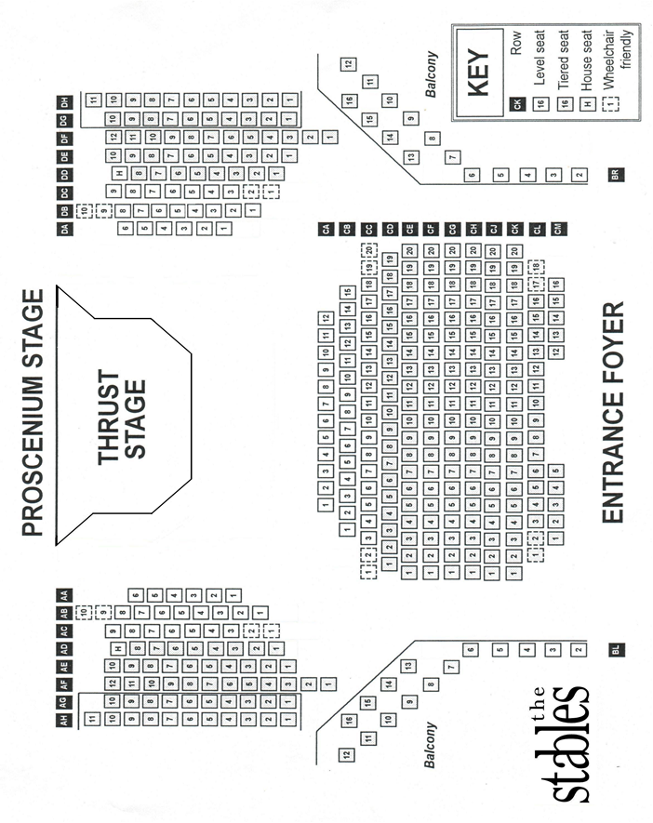

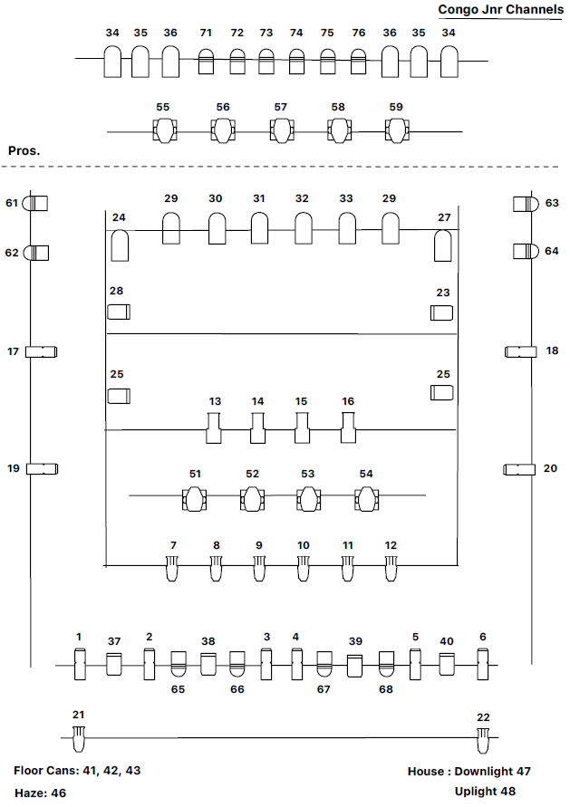

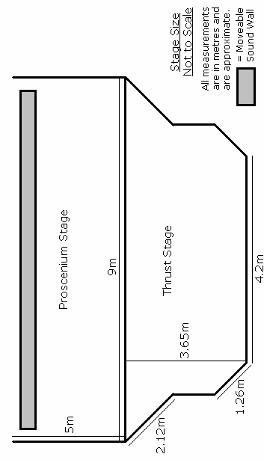

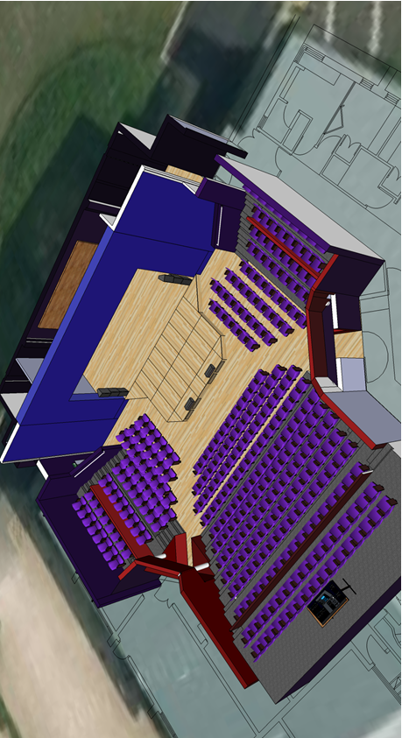
Stage and Auditorium Visual
Main House: Jim Marshall Auditorium

Full Capacity: 398 (including 8 disabled allocation),
6 seats removed if touring desk is in use. (244 straight on, 144 on side blocks)

Dimensions: Jim Marshall Auditorium: Proscenium stage with no rake, prompt corner S/L
Proscenium opening 9m/29ft, height 4.6m/15ft, depth without thrust 4m/13ft
with thrust 7.5m/24.5ft. Thrust narrows to 4.2m/13.5ft after extending 2.1m/6.9ft
Height to Grid 6.5m/21.3ft. Height to underside of towers 4m/13ft
Masking: U/S Blacks and 4 flats (2m/6ft x 5m/16.5ft)

